

Module: ST0280 Cloud and Service Computing

Class: DIT/FT/3A/23

Lecturer: Mr Ji Pengxiang

Submission Date: 07/02/2021

Team members:

Li Tianchu (1828568)

Li Zhangyi (1828542)

Wong Qing Er (1828708)

Gabriel Chen (1804403)

Sun Xiao Tang (1804429)

1. Application Features
   1. Basic Features

* View and change subscription plan



You can see your current plan at the product page

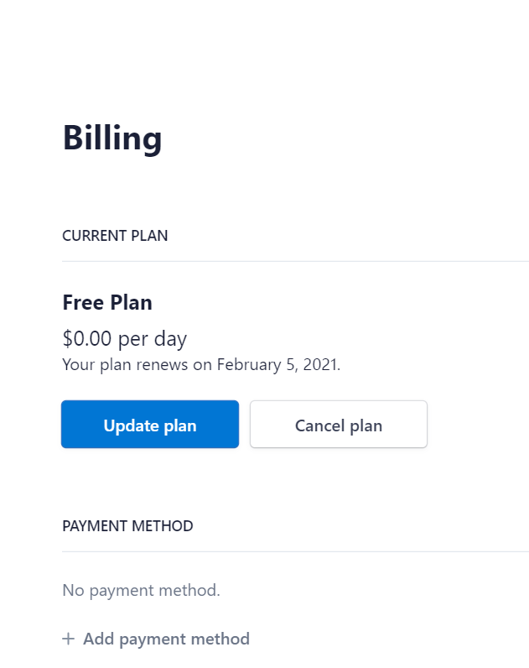

You can change the plan at customer portal, after you click “Manage Your Subscription” button

* Perform CRUD operations and comment on Talents



The talent page will list all the talent photos, on this page, you can perform Add operation.

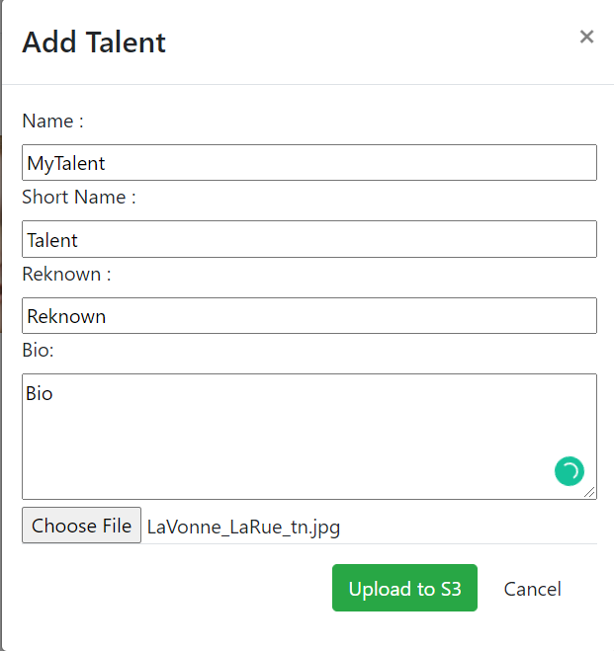

Add Talent form

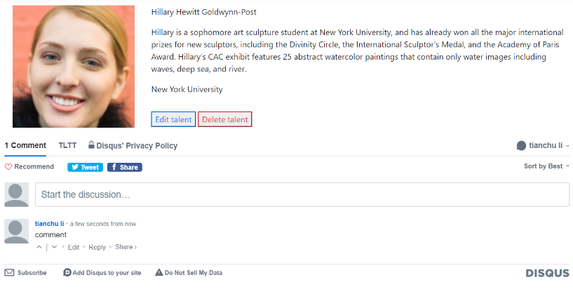

Click one of them, will direct to the page containing the talent details, you view the details, perform edit or delete operation, and comment on the talent profile.

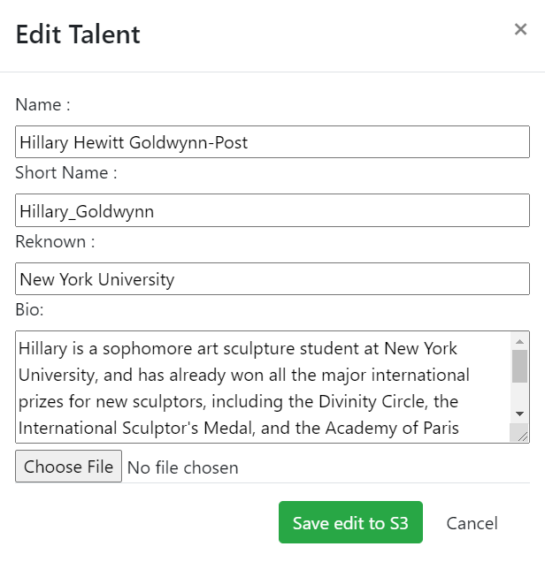

Edit Talent form

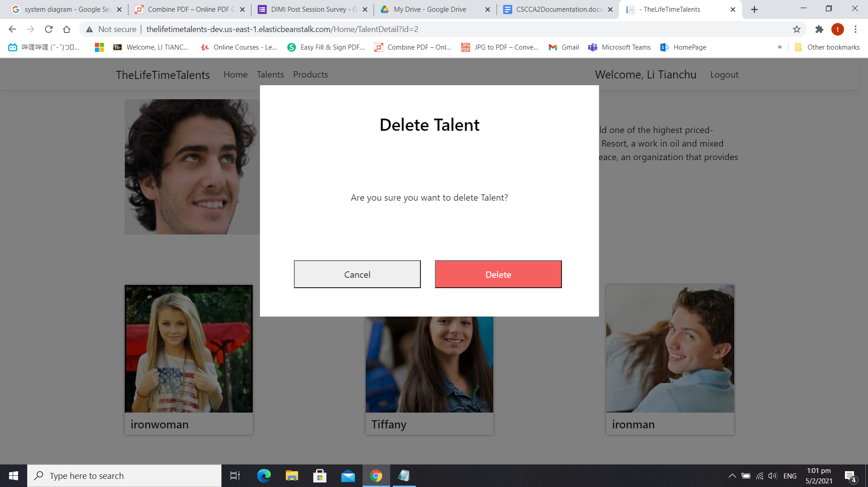

Delete Talent form

* Image recognition for talent photo

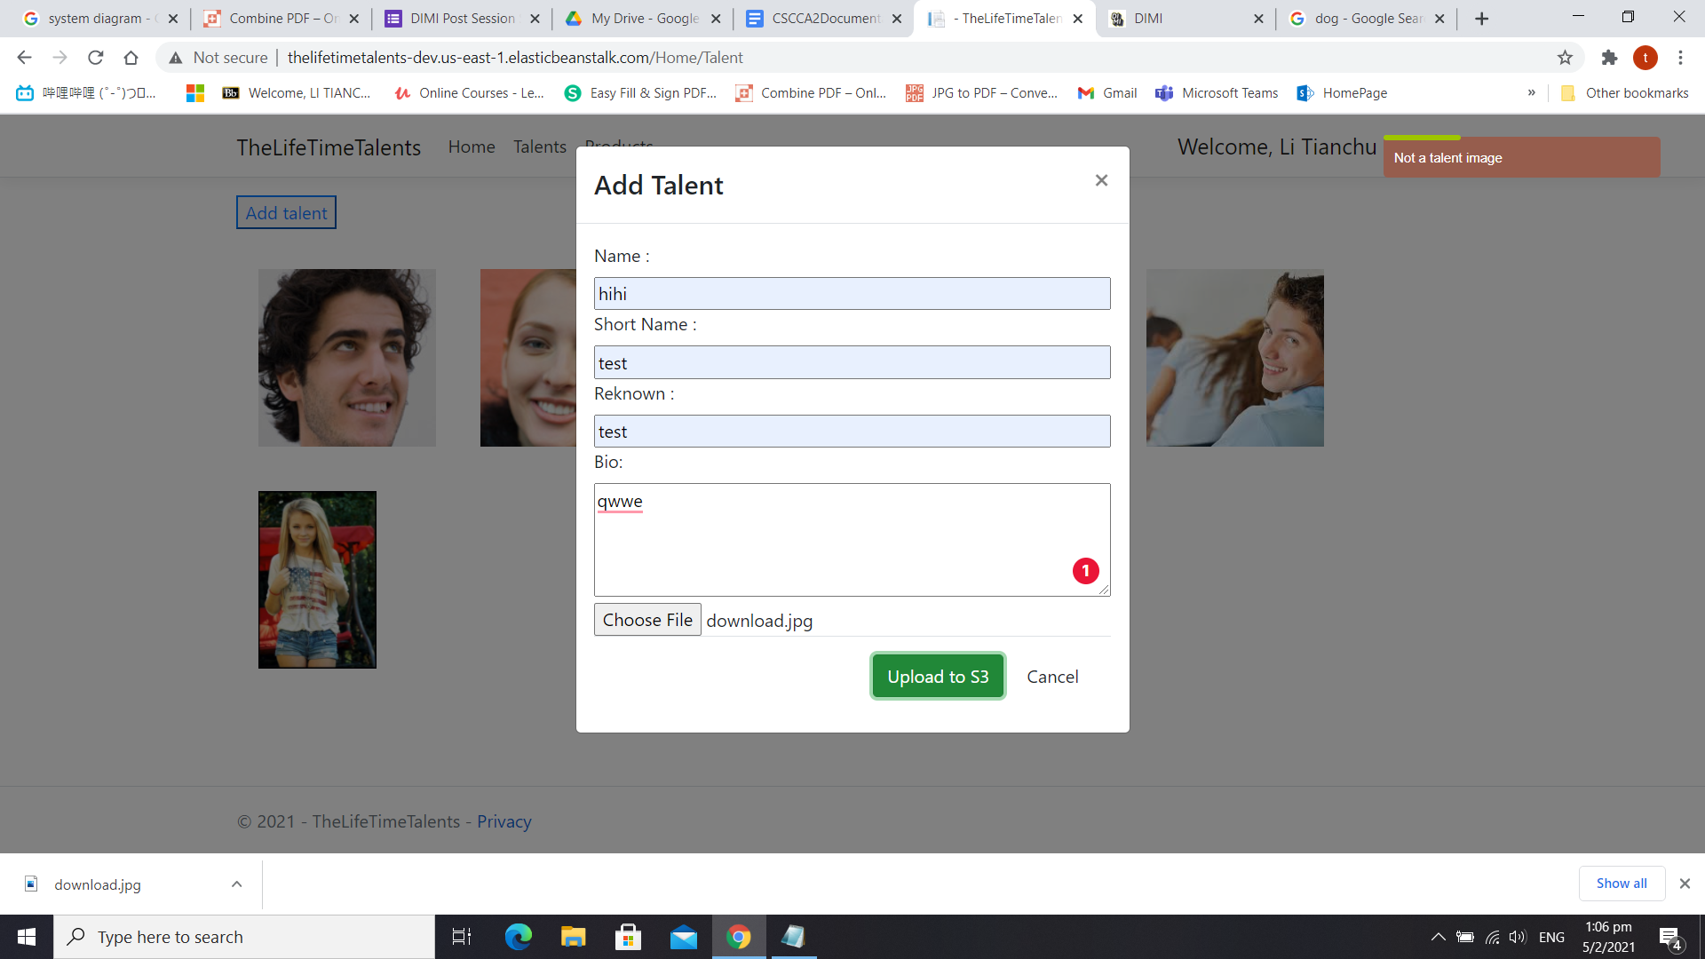

Error Message will be shown if the image is not a human being

* 1. Additional Features
* User Authentication

**Service used**: Google Identity Platform

**Business Impact**: Better security and save the time to build Identity Management system from the start

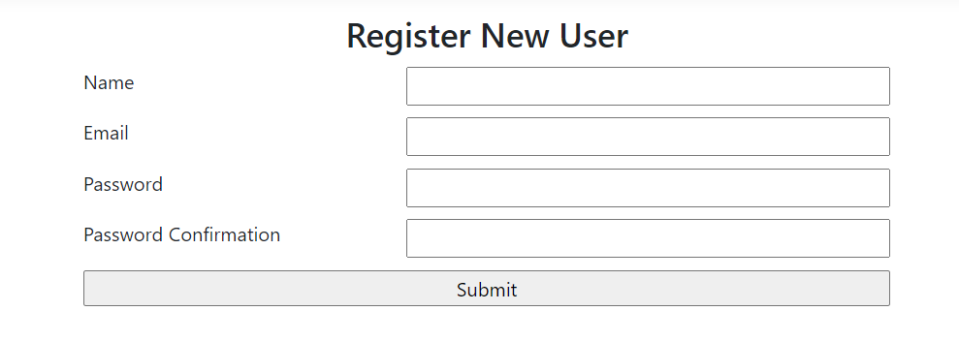

You can sign up by clicking the register button, the credentials will by stored in the google cloud identity platform.

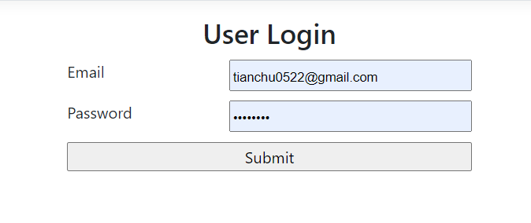

You can login if you have already created an account.



After you have logged in, Your name will be shown on the top bar, and there will be an option for you to log out.

**Code Snippet for register the user and add a customer to stripe**

firebase.auth().createUserWithEmailAndPassword(email, password)

.then((userCredential) => {

var user = firebase.auth().currentUser;

user.updateProfile({

displayName: name,

}).then(function () {

$.ajax({

method: "POST",

url: "/Stripe/AddCustomer",

data: { email: email,name:name }

}).done(function (data) {

window.location = "/";

}).fail(function (data) {

$.toast({

text: "Error occured when creating the customer information",

showHideTransition: 'slide',

bgColor: '#965d4d',

textColor: '#ffffff',

allowToastClose: false,

hideAfter: 3000,

stack: 5,

textAlign: 'left',

position: 'top-right'

});

});

}).catch(function (error) {

var errorMessage = error.message;

$.toast({

text: errorMessage,

showHideTransition: 'slide',

bgColor: '#965d4d',

textColor: '#ffffff',

allowToastClose: false,

hideAfter: 3000,

stack: 5,

textAlign: 'left',

position: 'top-right'

});

});

})

.catch((error) => {

var errorCode = error.code;

var errorMessage = error.message;

$.toast({

text: errorMessage,

showHideTransition: 'slide',

bgColor: '#965d4d',

textColor: '#ffffff',

allowToastClose: false,

hideAfter: 3000,

stack: 5,

textAlign: 'left',

position: 'top-right'

});

});

**Code Snippet for Sign-in the user**

firebase.auth().signInWithEmailAndPassword(email, password).then(() => {

window.location = "/";

}).catch(function (error) {

var errorMessage = error.message;

$.toast({

text: errorMessage,

showHideTransition: 'slide',

bgColor: '#965d4d',

textColor: '#ffffff',

allowToastClose: false,

hideAfter: 3000,

stack: 5,

textAlign: 'left',

position: 'top-right'

});

});

**Code Snippet for log out the user**

firebase.auth().signOut().then(() => {

// Sign-out successful.

window.location = "/";

}).catch((error) => {

var errorMessage = error.message;

$.toast({

text: errorMessage,

showHideTransition: 'slide',

bgColor: '#965d4d',

textColor: '#ffffff',

allowToastClose: false,

hideAfter: 3000,

stack: 5,

textAlign: 'left',

position: 'top-right'

});

});

* Recommendation

**Service used**: Recombee

**Business Impact**: Make content smarter by sharing the most popularly viewed talent.

See 2.12 for detail

**Code Snippet for displaying Recombee widget**

<script>window.recombeeIntegration=window.recombeeIntegration||function(){(recombeeIntegration.q=recombeeIntegration.q||[]).push(arguments)};recombeeIntegration.l=+new Date;</script>

<script>

recombeeIntegration({

"type": "SetDefaults",

"itemId": ITEM_ID,

"userId": USER_ID,

"publicToken": "gH4f8KmjXJOOX3Pat0chfKCTC2sugedv9RFS8hHRTzZSbsstgPmzf2TkwB1OkWCX",

"databaseId": "tltt-dev",

"rapiHostname": "client-rapi.recombee.com:443"

});

recombeeIntegration({

"type": "AddDetailView"

});

recombeeIntegration({

"type": "InitializeRecommendationWidget",

"rootElementId": "widget-root-0308a7d8-9336-4730-a1ef-38a6e19bc672",

"widgetId": "0308a7d8-9336-4730-a1ef-38a6e19bc672"

});

</script>

<script defer src="https://web-integration.recombee.com/v1/recombee.js"></script>

<div id="widget-root-0308a7d8-9336-4730-a1ef-38a6e19bc672"></div>

**Code Snippet for server side Recombee passing item value**

var client = new RecombeeClient("tltt-dev", "74NU7KLeUUpTMFtFTpPUhQGEduqdpRoTFMR1548aUtLzDdWdACb6OnIzrVTYzjAC");

client.Send(new SetItemValues(t.Id+"",

new Dictionary<string, object>() {

{"name", t.Name},

{"talentImg", t.Profile},

{"link", "http://thelifetimetalents-dev.us-east-1.elasticbeanstalk.com/Home/TalentDetail?id="+t.Id },

{"deleted", false}

},

cascadeCreate: true

));

**Code Snippet for client side passing of Recombee interaction**

**(view count)**

client.send(new recombee.AddDetailView(userId, id+""),

(err, response) => {

//...

}

);

* Serverless API Architecture

Service used: Amazon Lambda

Business Impact: Lower the cost and increase development speed

See 2.7 and 2.8 for detail

1. Web Services
   1. Amazon EC2 (Client Hosting)

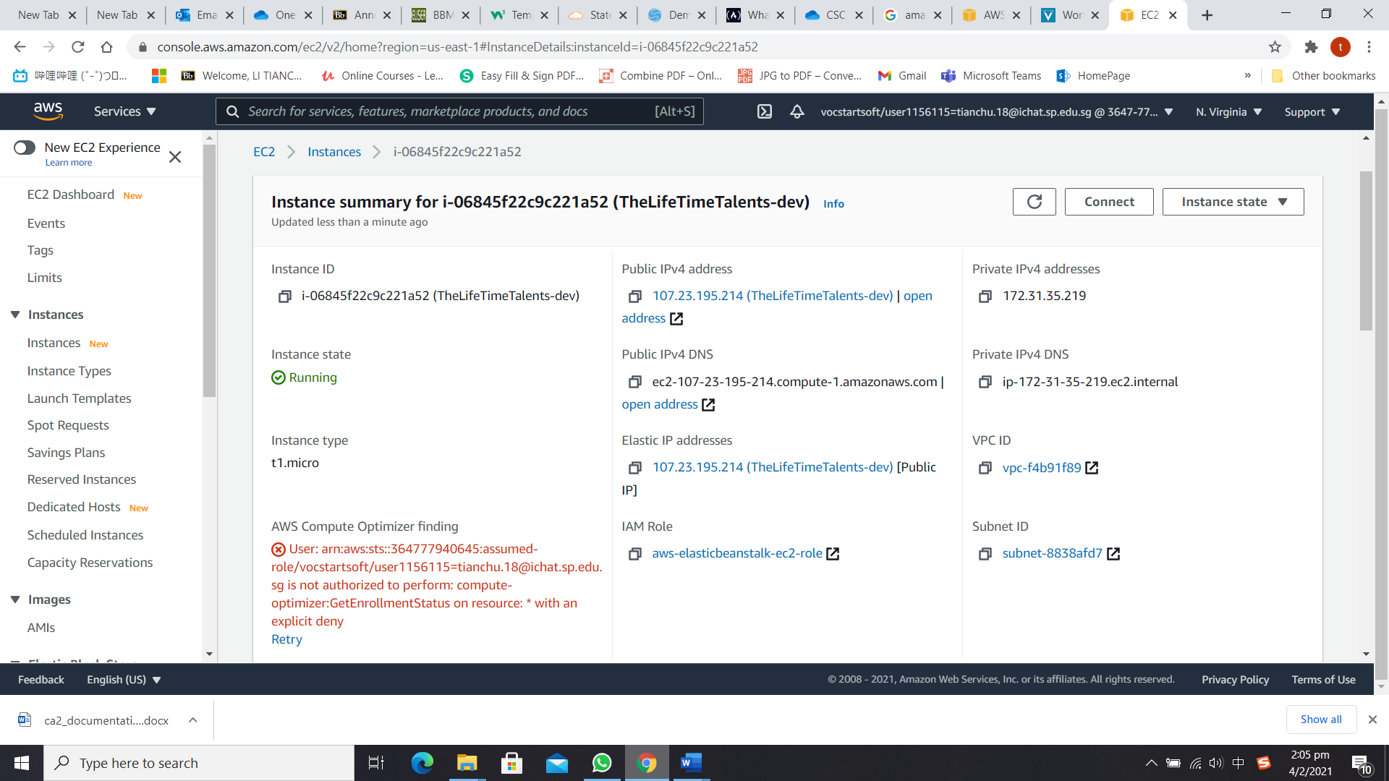

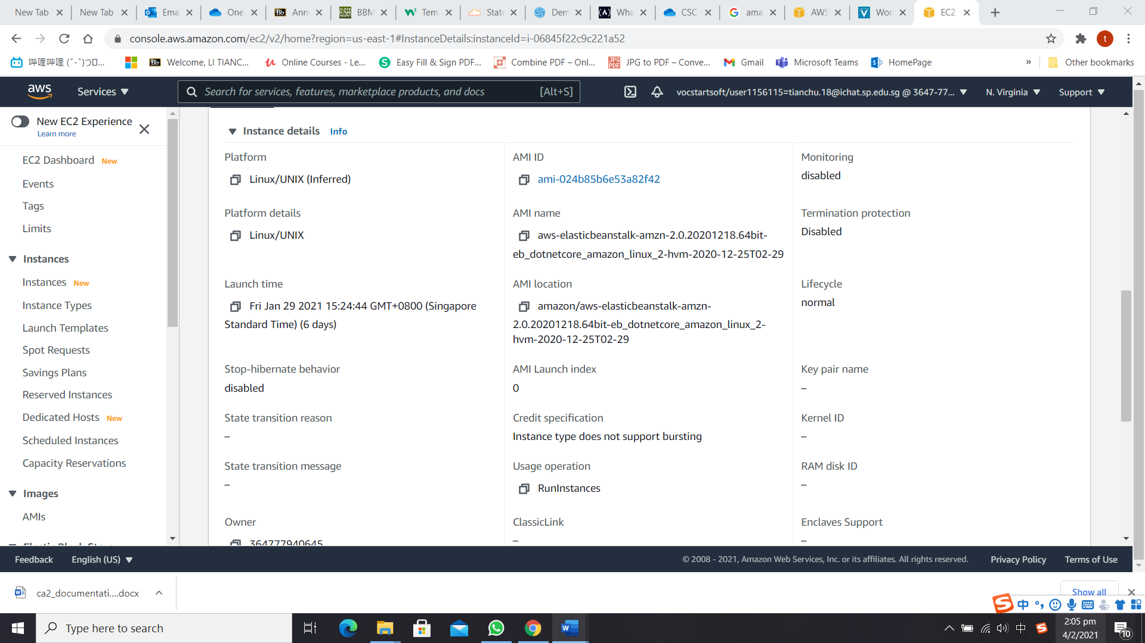

The instance that is running our website**(url:** [**http://thelifetimetalents-dev.us-east-1.elasticbeanstalk.com/**](http://thelifetimetalents-dev.us-east-1.elasticbeanstalk.com/)**).**

* 1. Google Identity Platform (Identity Management)

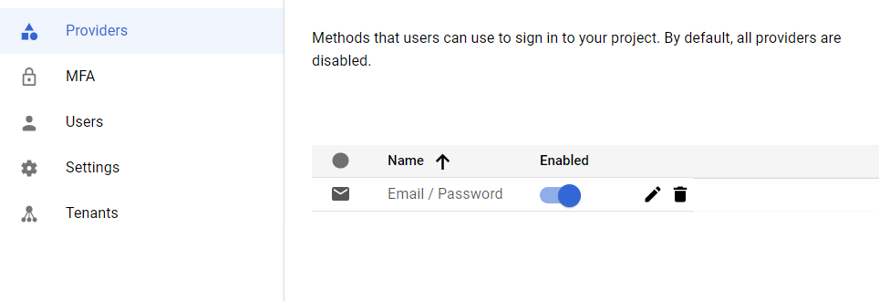

The login method is set to Email/Password

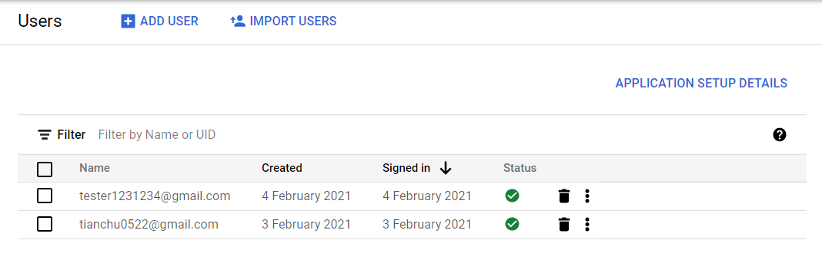

The identities are contained and management inside the platform

* 1. Amazon S3 (Image Storage)

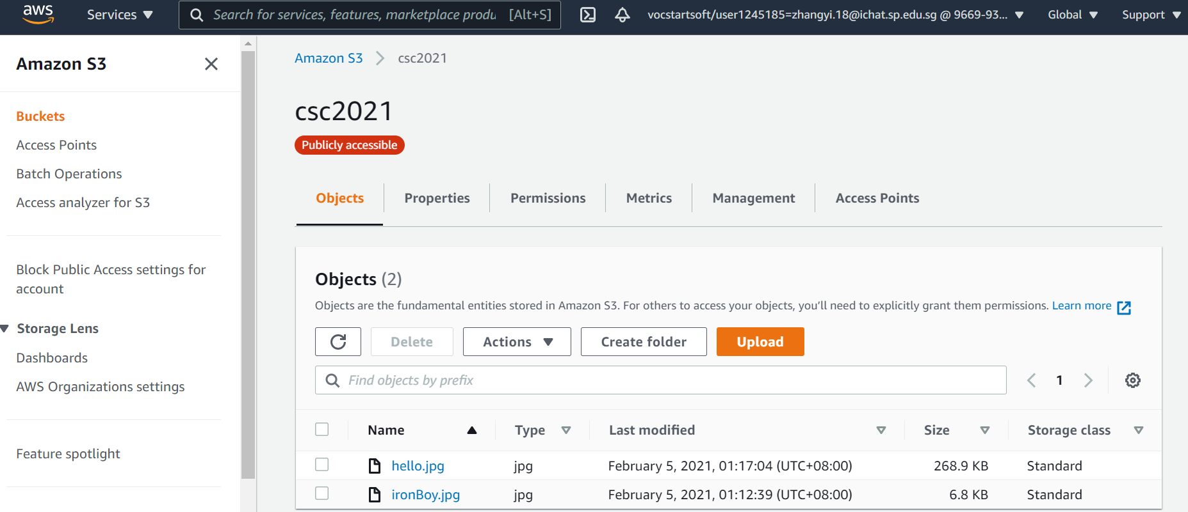

After being validated by clarifai, the images are uploaded and stored here.

* 1. Amazon RDS (SQL Database)

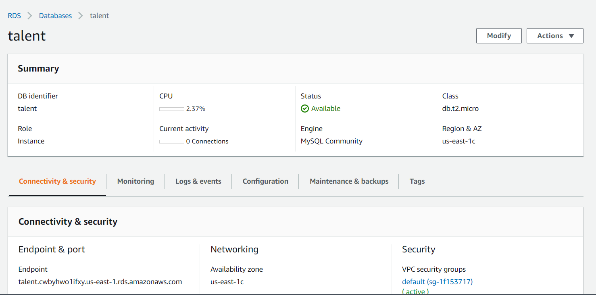

The MySQL database that is running on RDS

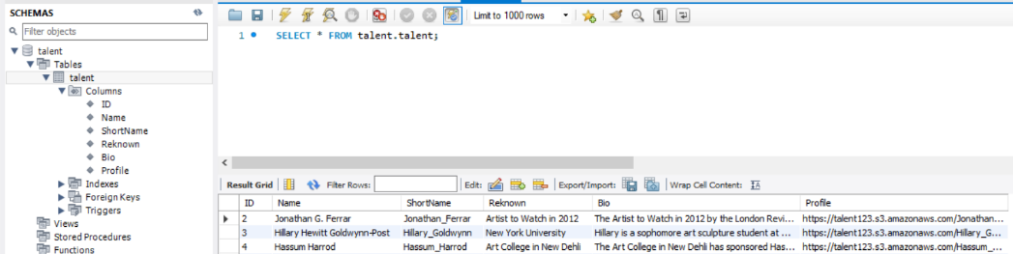

The columns in the talent table, it is used to support CRUD operations for the talent

* 1. Amazon DynamoDB (No-SQL Database)

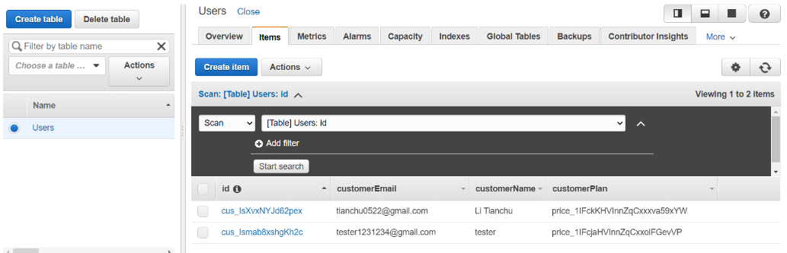

The NO-SQL database that is running on DynamoDB, to store the User related information.

* 1. Amazon Redshift (Data Warehouse)

**The aws educate account that we used cannot access the service(no permission), so we will just highlight the steps that we obtained from research.**

1. Create a S3 bucket for storing the talent and user data.
2. Export the data into csv files

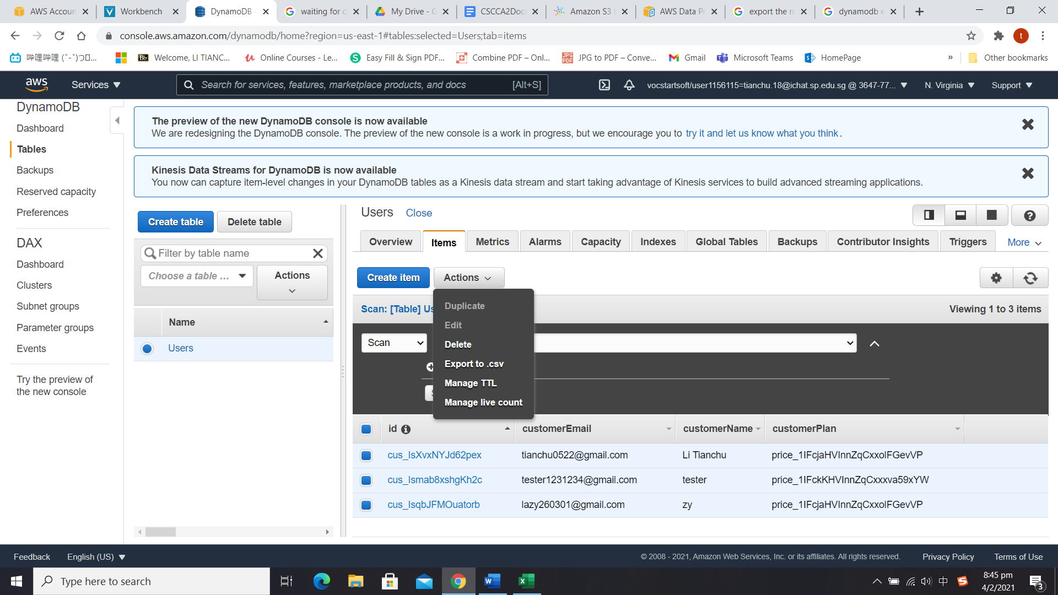

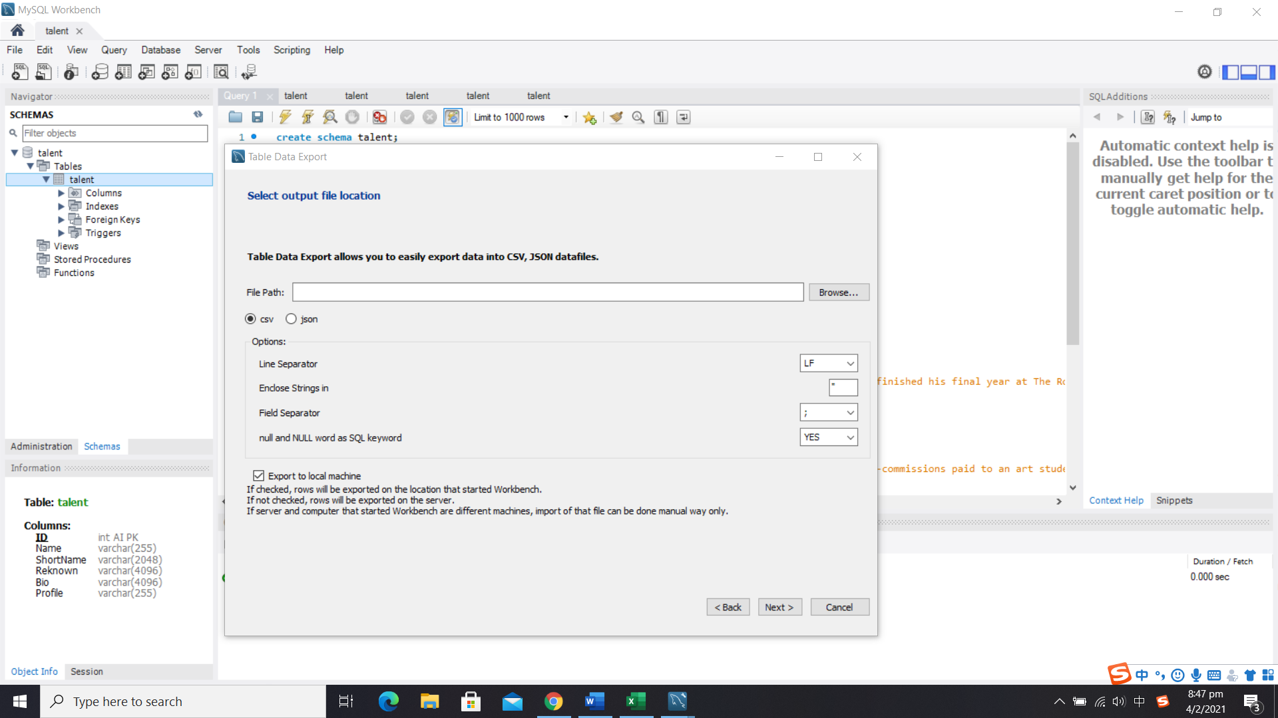

1. Upload the csv files to the S3 bucket created in step1
2. Launch a Redshift cluster and create respective database tables
3. Use COPY commands to load the tables from the data files on Amazon S3.

**copy catdemo**

**from 's3://talents3/talent/talent.csv'**

**iam_role 'arn:aws:iam::*<aws-account-id>*:role/*<role-name>*'**

**region 'us-east-1';**

**(sample copy command)**

1. Check for copy errors and modify the copy command if needed
   1. Amazon Lambda (API Hosting)

For refactoring the application to have serverless architecture

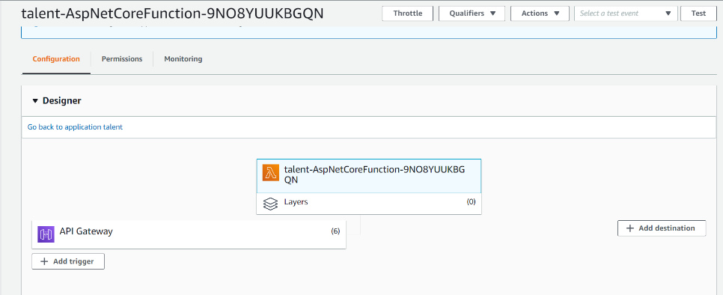

The Talent API endpoint**(url: https://rcfl5otx2c.execute-api.us-east-1.amazonaws.com/Prod)** that is hosted on Lambda

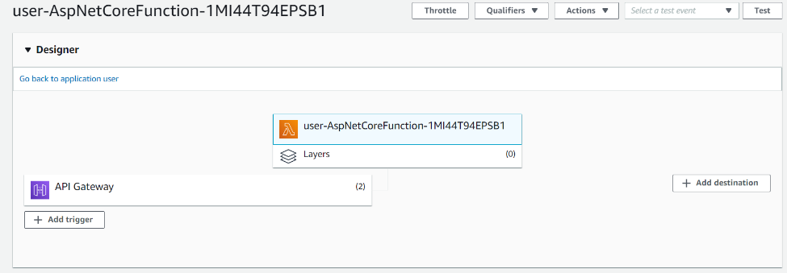

The User API endpoint**(url: https://p6aplnpyw8.execute-api.us-east-1.amazonaws.com/Prod)** that is hosted on Lambda

* 1. Amazon API Gateway & CloudWatch (API Management and Logging)

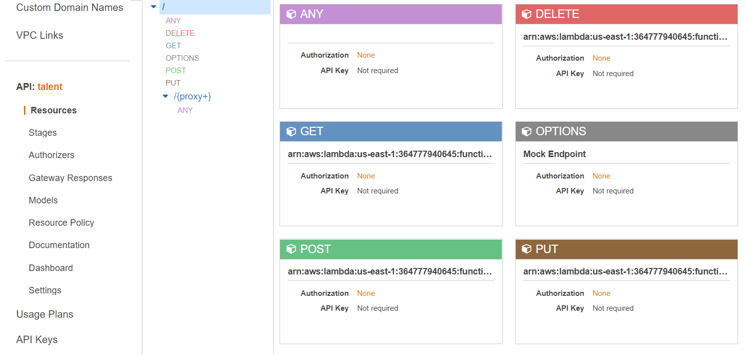

API gateway that monitors the various operations on the Talent API

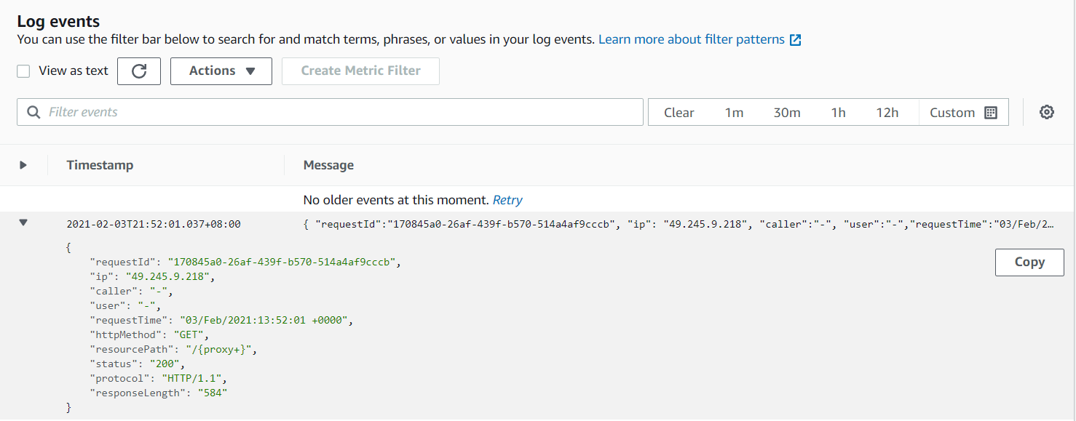

The Source IP, httpMethod, Status code, Response Time, Response Length are monitored and recorded by CloudWatch.

* 1. Clarifai (Image Recognition)

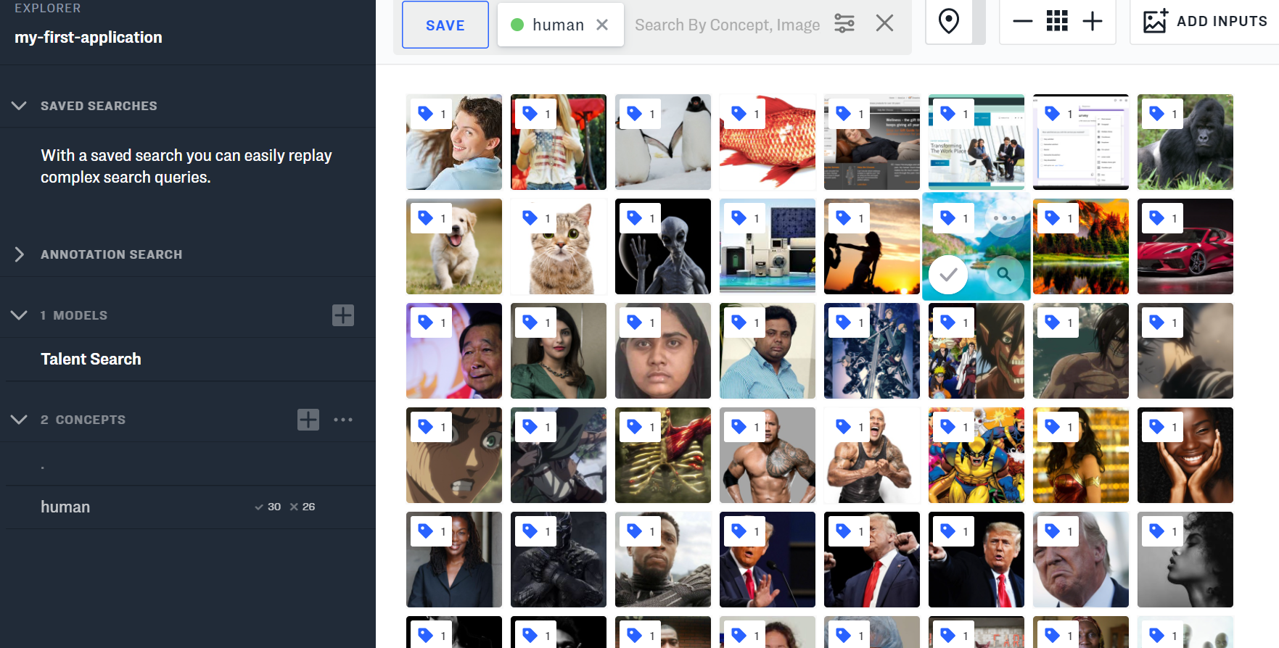

Images are uploaded with the concept defined for that image to train the model. Thus, enable the model to define the concept for various images.

* 1. Stripe (Payment Management)

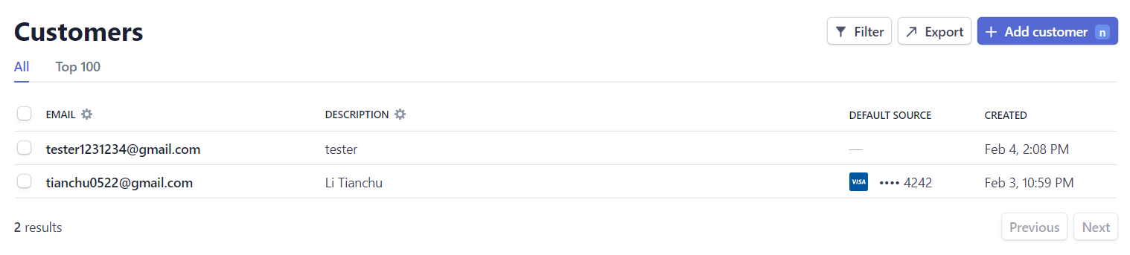

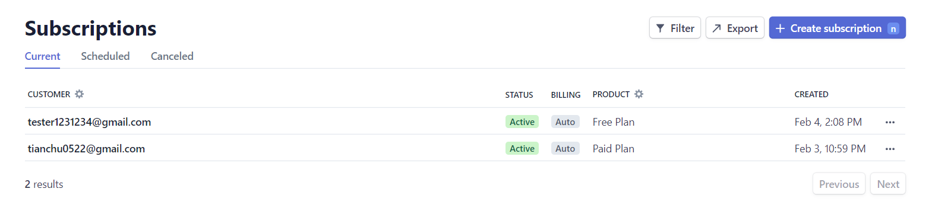

Customers and their subscriptions are managed in the Stripe Dashboard.

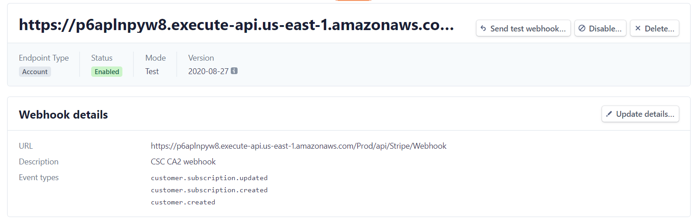

The webhook that listens to the webhook endpoint <https://p6aplnpyw8.execute-api.us-east-1.amazonaws.com/Prod/api/Stripe/Webhook>

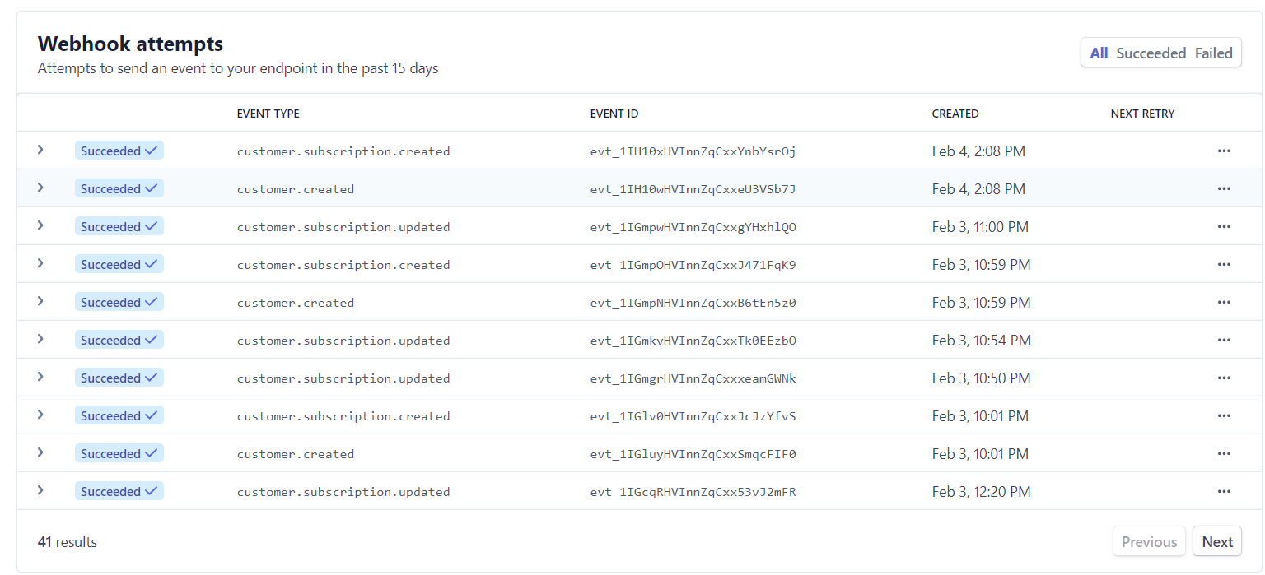

The events that are recorded including: customer.created, customer.subscription.created, customer.subscription.updated

* 1. Disqus (Discussion Management)

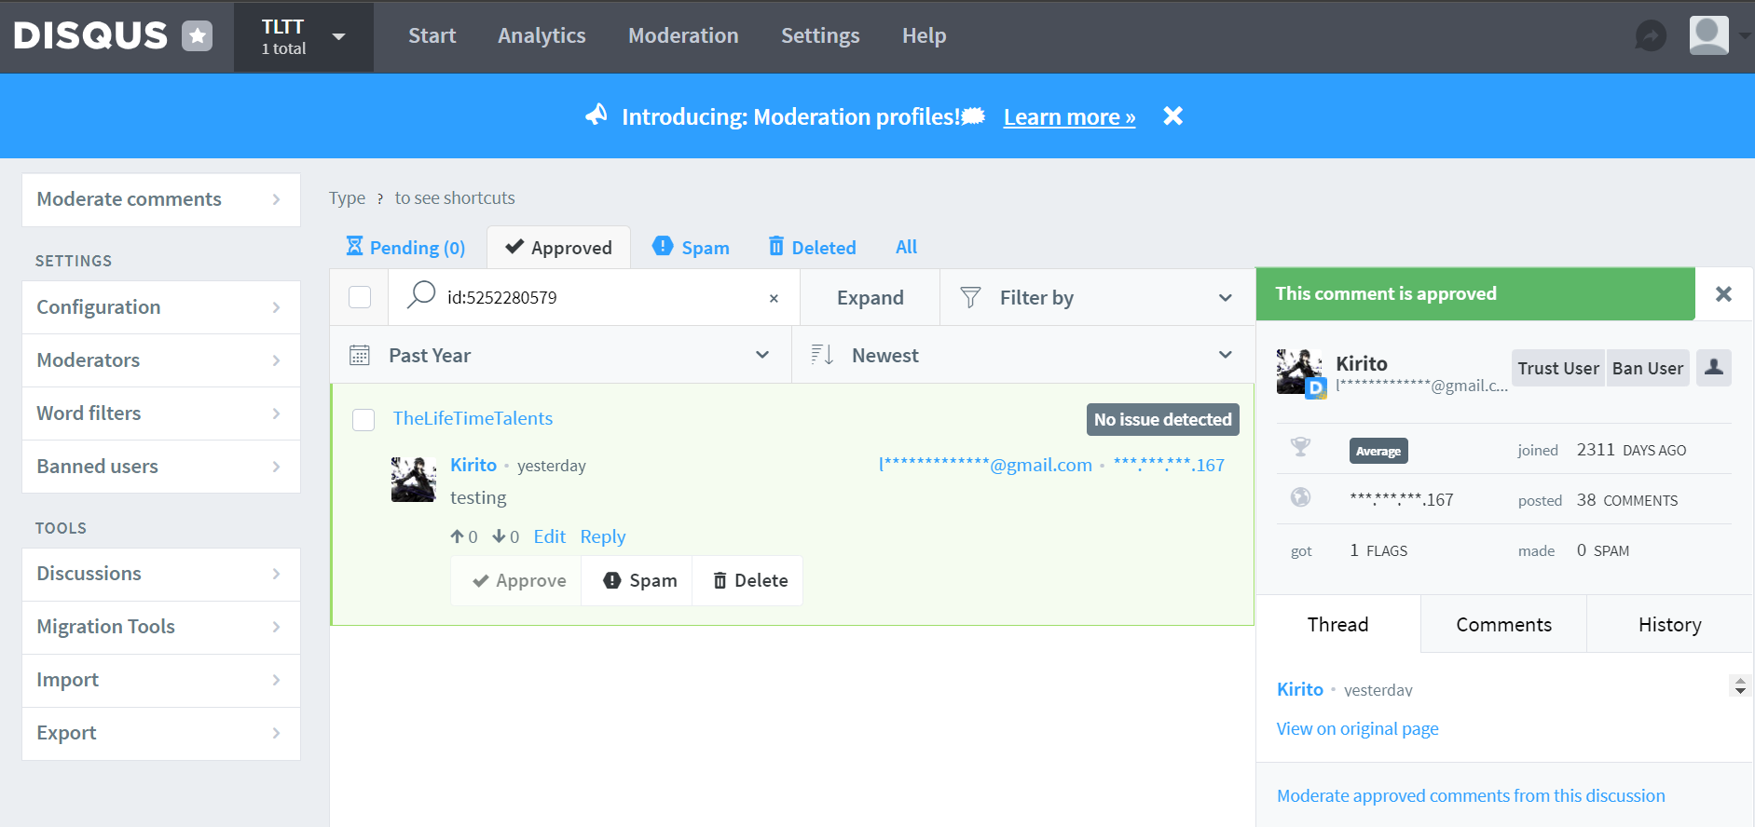

User and their comment are managed here for various talent page

* 1. Recombee (Recommendation)

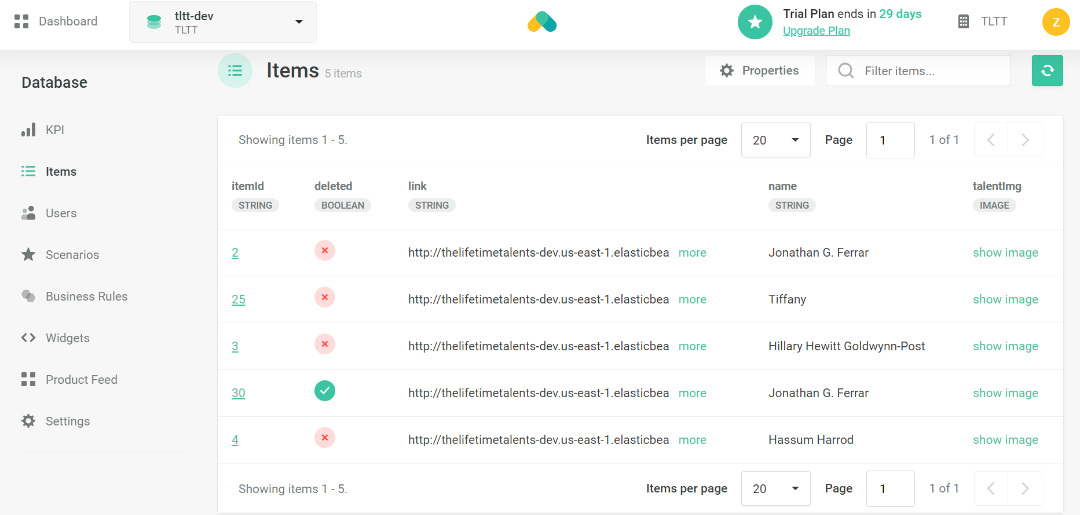

This is where the data for recommendation is stored. The data is pass to to Recombee database in talentApi the code is found under 1.2 recommendation Code Snippet for server side Recombee passing item value

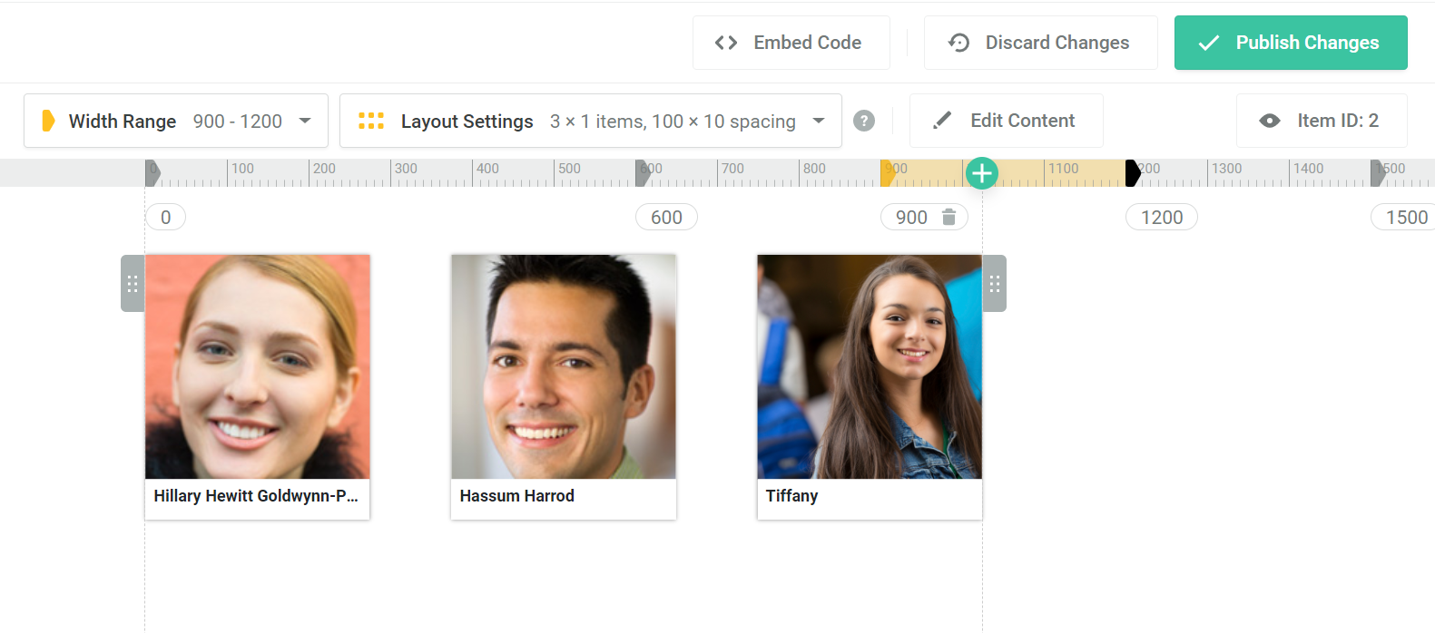

This is the widget we created and used to display our recommendation based on the scenario we choose. We display our talent by their popularity(view collected).

1. Cross Browser Testing

For the cross browser testing, we use Lambdatest as a tool to test the website, refer to the screenshot below to see the testing result on different browsers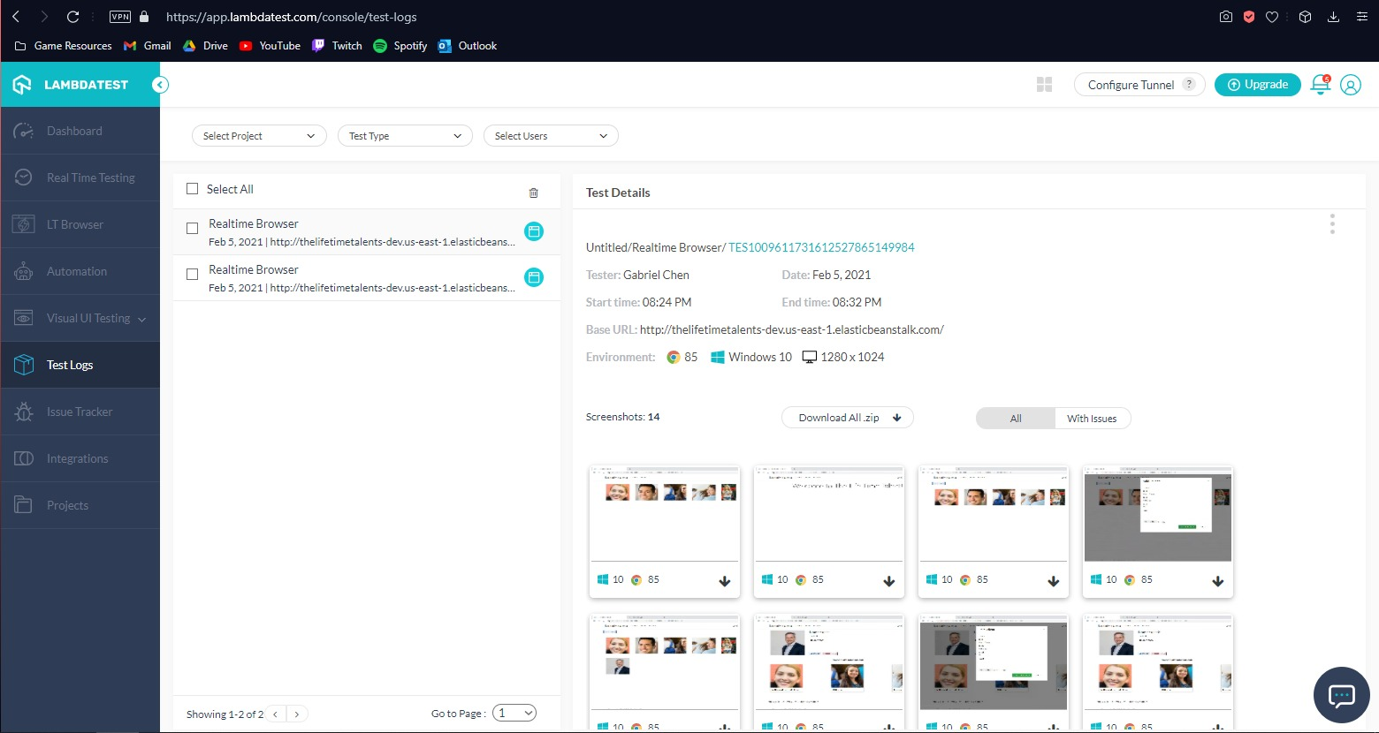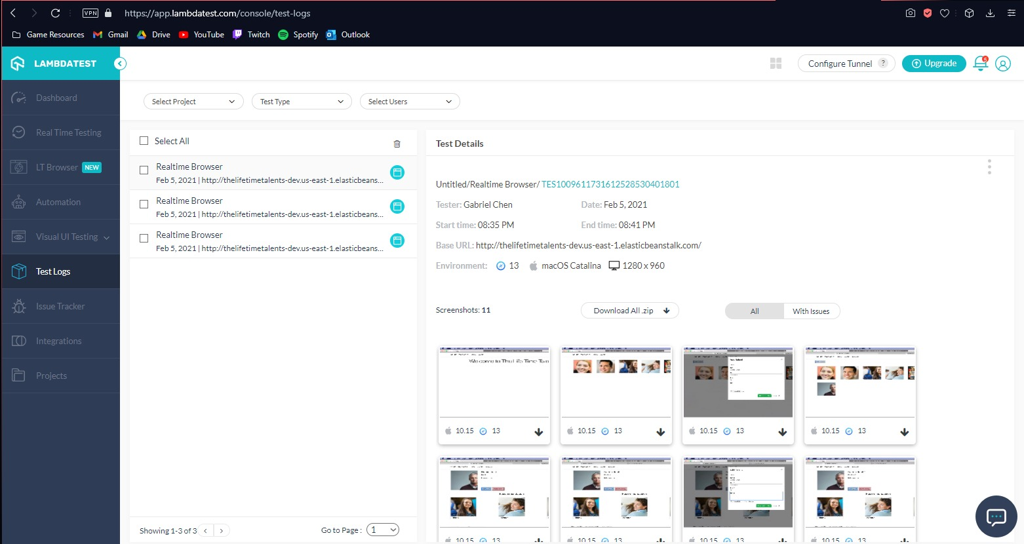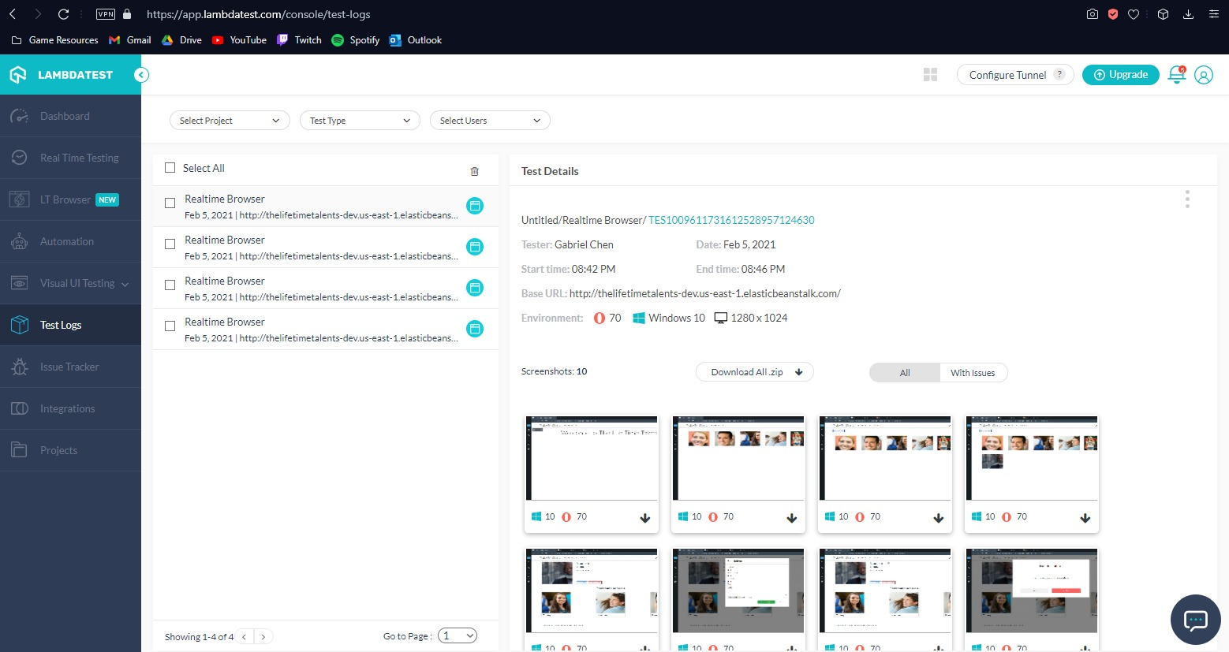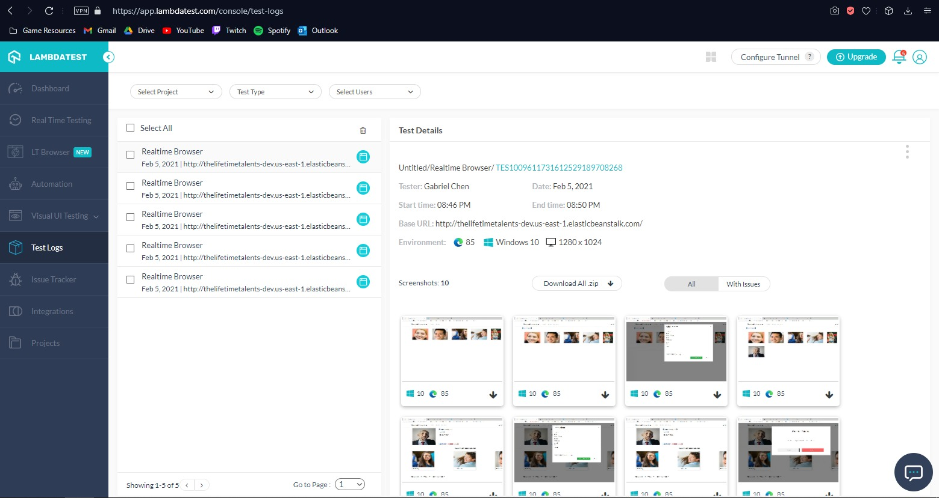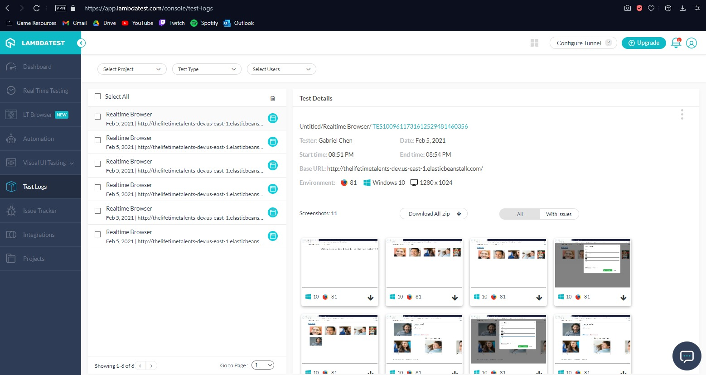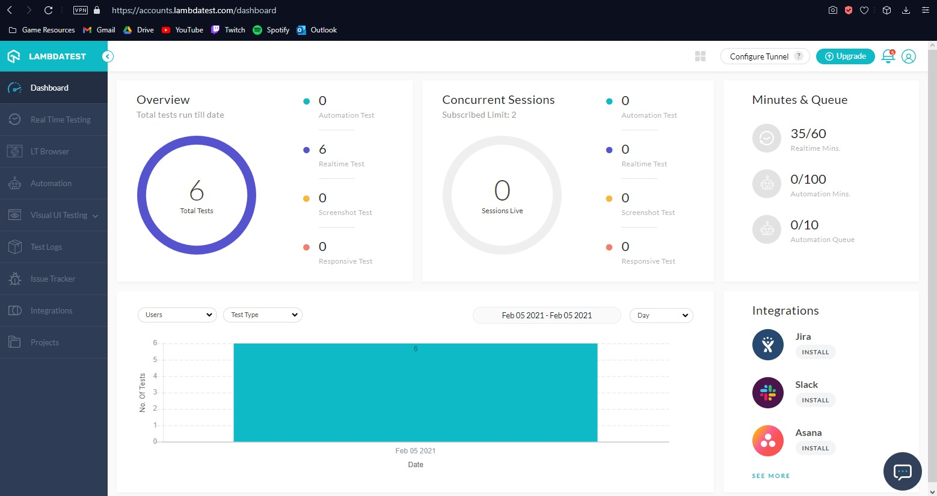

1. API Documentation
   1. GetAllTalent

|  |  |
| --- | --- |
| API | GetAllTalent |
| Endpoint | https://rcfl5otx2c.execute-api.us-east-1.amazonaws.com/Prod |
| URL | /api/Talent/GetAllTalent |
| Method | GET |
| Query Params | / |
| Body(Type:Json) | / |
| Success Status Code | 200 |
| Response Json Sample | [      {          "id": 2,          "name": "Jonathan G. Ferrar",          "shortName": "Jonathan_Ferrar",          "profile": "https://talent123.s3.amazonaws.com/Jonathan_Ferrar_tn.jpg",          "bio": "The Artist to Watch in 2012 by the London Review, Johnathan has already sold one of the highest priced-commissions paid to an art student, ever on record. The piece, entitled Gratitude Resort, a work in oil and mixed media, was sold for $750,000 and Jonathan donated all the proceeds to Art for Peace, an organization that provides college art scholarships for creative children in developing nations",          "reknown": "Artist to Watch in 2012"      },      {          "id": 3,          "name": "Hillary Hewitt Goldwynn-Post",          "shortName": "Hillary_Goldwynn",          "profile": "https://talent123.s3.amazonaws.com/Hillary_Goldwynn_tn.jpg",          "bio": "Hillary is a sophomore art sculpture student at New York University, and has already won all the major international prizes for new sculptors, including the Divinity Circle, the International Sculptor's Medal, and the Academy of Paris Award. Hillary's CAC exhibit features 25 abstract watercolor paintings that contain only water images including waves, deep sea, and river.",          "reknown": "New York University"      },  ] |
| Screen Shot |  |

* 1. GetTalentById

|  |  |
| --- | --- |
| API | GetTalentById |
| EndPoint | https://rcfl5otx2c.execute-api.us-east-1.amazonaws.com/Prod |
| URL | /api/Talent/GetTalentById/{id:int} |
| Method | GET |
| Query Params | / |
| Body(Type:Json) | / |
| Success Status Code | 200 |
| Response Json Sample | {      "id": 2,      "name": "Jonathan G. Ferrar",      "shortName": "Jonathan_Ferrar",      "profile": "https://talent123.s3.amazonaws.com/Jonathan_Ferrar_tn.jpg",      "bio": "The Artist to Watch in 2012 by the London Review, Johnathan has already sold one of the highest priced-commissions paid to an art student, ever on record. The piece, entitled Gratitude Resort, a work in oil and mixed media, was sold for $750,000 and Jonathan donated all the proceeds to Art for Peace, an organization that provides college art scholarships for creative children in developing nations",      "reknown": "Artist to Watch in 2012"  } |
| Screen Shot |  |

* 1. PostTalent

|  |  |
| --- | --- |
| API | PostTalent |
| EndPoint | https://rcfl5otx2c.execute-api.us-east-1.amazonaws.com/Prod |
| URL | /api/Talent/PostTalent |
| Method | POST |
| Query Params | / |
| Body(Type:Json) | {  “Name”: “Example Name”,  “ShortName”: “Example”,  “Reknown”:”Example Reknown”,  “Bio”:”Example Bio”,  “Profile”:”http://example.com/example.jpg”  } |
| Success Status Code | 200 |
| Response Json Sample | / |
| Screen Shot |  |

* 1. PutTalent

|  |  |
| --- | --- |
| API | PutTalent |
| EndPoint | https://rcfl5otx2c.execute-api.us-east-1.amazonaws.com/Prod |
| URL | /api/Talent/PutTalent/{id:int} |
| Method | PUT |
| Query Params | / |
| Body(Type:Json) | {  “Name”: “Updated Name”,  “ShortName”: “Updated”,  “Reknown”:” Updated Reknown”,  “Bio”:” Updated Bio”,  “Profile”:”http://example.com/updatedexample.jpg”  } |
| Success Status Code | 200 |
| Response Json Sample | / |
| Screen Shot |  |

* 1. DeleteTalent

|  |  |
| --- | --- |
| API | DeleteTalent |
| EndPoint | https://rcfl5otx2c.execute-api.us-east-1.amazonaws.com/Prod |
| URL | /api/Talent/DeleteTalent/{id:int} |
| Method | DELETE |
| Query Params | / |
| Body(Type:Json) | / |
| Success Status Code | 200 |
| Response Json Sample | / |
| Screen Shot |  |

* 1. GetUser

|  |  |
| --- | --- |
| API | GetUser |
| EndPoint | https://p6aplnpyw8.execute-api.us-east-1.amazonaws.com/Prod |
| URL | /api/DynamoDb/GetUser |
| Method | GET |
| Query Params | customerId : string |
| Body(Type:Json) | / |
| Success Status Code | 200 |
| Response Json Sample | {      "users": [          {              "id": "cus_IsXvxNYJd62pex",              "customerEmail": "tianchu0522@gmail.com",              "customerName": "Li Tianchu",              "plan": "price_1IFckKHVInnZqCxxxva59xYW"          }      ]  } |
| Screen Shot |  |

* 1. AddUser

|  |  |
| --- | --- |
| API | AddUser |
| EndPoint | https://p6aplnpyw8.execute-api.us-east-1.amazonaws.com/Prod |
| URL | /api/DynamoDb/AddUser |
| Method | POST |
| Query Params | customerId: string  email: string  name: string  plan: string |
| Body(Type:Json) | / |
| Success Status Code | 200 |
| Response Json Sample | / |
| Screen Shot |  |

* 1. UpdateUser

|  |  |
| --- | --- |
| API | UpdateUser |
| EndPoint | https://p6aplnpyw8.execute-api.us-east-1.amazonaws.com/Prod |
| URL | /api/DynamoDb/UpdateUser |
| Method | PUT |
| Query Params | customerId: string  plan: string |
| Body(Type:Json) | / |
| Success Status Code | 200 |
| Response Json Sample | {      "id": "cus_example",      "customerEmail": **null**,      "customerName": **null**,      "plan": "updatedPlan"  } |
| Screen Shot |  |

* 1. GetAllProducts

|  |  |
| --- | --- |
| API | GetAllProducts |
| EndPoint | http://thelifetimetalents-dev.us-east-1.elasticbeanstalk.com |
| URL | /stripe/GetAllProducts |
| Method | GET |
| Query Params | / |
| Body(Type:Json) | / |
| Success Status Code | 200 |
| Response Json Sample | {      "contentType": **null**,      "serializerSettings": **null**,      "statusCode": **null**,      "value": [          {              "id": "prod_IrLRYTKAywOcaJ",              "priceId": "price_1IFckKHVInnZqCxxxva59xYW",              "name": "Paid Plan",              "amount": 10          },          {              "id": "prod_IrLQrqavLCirBD",              "priceId": "price_1IFcjaHVInnZqCxxolFGevVP",              "name": "Free Plan",              "amount": 0          }      ]  } |
| Screen Shot |  |

* 1. GetSubscription

|  |  |
| --- | --- |
| API | GetSubscription |
| EndPoint | http://thelifetimetalents-dev.us-east-1.elasticbeanstalk.com/ |
| URL | /stripe/GetSubscription |
| Method | GET |
| Query Params | customerId : string |
| Body(Type:Json) | / |
| Success Status Code | 200 |
| Response Json Sample | {      "contentType": **null**,      "serializerSettings": **null**,      "statusCode": **null**,      "value": [          {              "id": "sub_IsXvzfDc6kQ0kH",              "prodId": "prod_IrLRYTKAywOcaJ",              "priceId": "price_1IFckKHVInnZqCxxxva59xYW"          }      ]  } |
| Screen Shot |  |

* 1. GetCustomer

|  |  |
| --- | --- |
| API | GetCustomer |
| EndPoint | http://thelifetimetalents-dev.us-east-1.elasticbeanstalk.com/ |
| URL | /stripe/GetCustomer |
| Method | GET |
| Query Params | email : string |
| Body(Type:Json) | / |
| Success Status Code | 200 |
| Response Json Sample | {      "contentType": **null**,      "serializerSettings": **null**,      "statusCode": **null**,      "value": [          {              "id": "cus_IsXvxNYJd62pex",              "name": "Li Tianchu",              "amount": 1000          }      ]  } |
| Screen Shot |  |

* 1. AddCustomer

|  |  |
| --- | --- |
| API | Add Customer |
| EndPoint | http://thelifetimetalents-dev.us-east-1.elasticbeanstalk.com/ |
| URL | /stripe/AddCustomer |
| Method | POST |
| Query Params | email:string  name:string |
| Body(Type:Json) | / |
| Success Status Code | 200 |
| Response Json Sample | / |
| Screen Shot |  |

1. System Diagram